Effective Communication - Pyramid Principle

**|| Purpose ||**

The *Pyramid Principle* (Minto, 1978) is a powerful tool for organizing and communicating ideas clearly and effectively. It involves structuring thinking in a logical and hierarchical way to ensure the most important information is presented first.

**|| Guiding Principles ||**

1. Start with the context and main recommendation: Situation, Complication, Question, Answer.
2. Summarize the supporting arguments.
3. Present the evidence for each argument.
4. Following the pyramid structure allows the audience to agree with your recommendation and move ahead without getting into all the details.

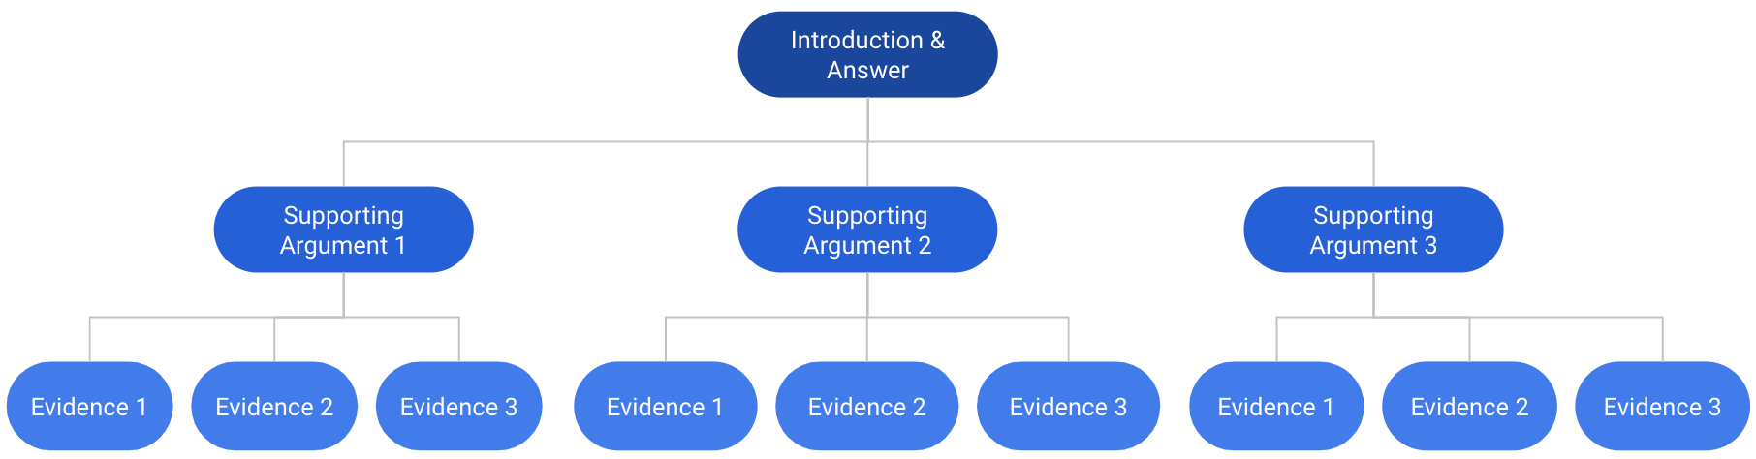

**|| Sample Outline - Should Microsoft Acquire Nuance Communications? ||**

1. Situation: state of the healthcare technology market in 2021, relevant data or trends that suggest a need for advanced artificial intelligence (AI) and natural language processing (NLP) technologies in healthcare, potential benefits of entering the healthcare technology market for Microsoft.
2. Complication: challenges and risks associated with acquiring a large company like Nuance Communications, including regulatory hurdles and integration challenges.
3. Question: should Microsoft acquire Nuance Communications?
4. Answer: Yes, Microsoft should acquire Nuance Communications.
5. Supporting Argument 1: There is a big opportunity for increased revenue and market share in the healthcare technology market.
6. Supporting Argument 2: This is an opportunity to differentiate Microsoft from competitors and build a strong reputation in the healthcare industry.
7. Supporting Argument 3: There is potential to expand Microsoft's AI and NLP capabilities to other industries.
8. Evidence for Argument 1: There is a big opportunity for increased revenue and market share in the healthcare technology market.
   1. Google's acquisition of Fitbit in 2019 for $2.1 billion allowed them to enter the wearable technology market and increase their revenue in the health and wellness industry.
   2. Amazon's acquisition of PillPack in 2018 for $753 million allowed them to enter the pharmacy industry and potentially capture a portion of the $300 billion prescription drug market.
   3. Apple's partnership with Epic Systems, a leading electronic health records company, allowed them to integrate their health app into Epic's software and potentially increase revenue from healthcare-related services.
9. Evidence for Argument 2: This is an opportunity to differentiate Microsoft from competitors and build a strong reputation in the healthcare industry.
   1. IBM's acquisition of Merge Healthcare in 2015 for $1 billion allowed them to enhance their healthcare technology capabilities and establish themselves as a leader in medical imaging and analysis.
   2. Salesforce's acquisition of Vlocity in 2020 for $1.33 billion allowed them to strengthen their position in the healthcare industry and offer more customized solutions for healthcare providers.
   3. Google's partnership with Mayo Clinic to develop AI-powered tools for healthcare providers allowed them to differentiate themselves from competitors and establish themselves as a leader in healthcare technology.
10. Evidence for Argument 3: There is potential to expand Microsoft's AI and NLP capabilities to other industries.
    1. Amazon's acquisition of Ring, a home security company, in 2018 allowed them to expand their AI and NLP capabilities to the home automation market.
    2. Google's acquisition of DeepMind in 2015 allowed them to expand their AI capabilities beyond search and advertising and into other industries like healthcare and energy.
    3. Microsoft's partnership with OpenAI to develop advanced AI and NLP technologies allowed them to potentially expand their capabilities to industries like finance and manufacturing.